**Week 13**

**TEAM MEETING**

***Cameron,*** *Diogo, Jose, Samuel, Yujui, Lio*

## Notes from meetings throughout the week

**Electronics**

Motor

* I had connected the motor and gearbox and changed some config on Odrive. The motor and gearbox can start the calibration but need to notice the backdrive of the motor to the shaft.

Touch Screen

* The touch screen from sunFounder just can trace one finger which is like the function of mouse
* We need to change to another touch screen which has the ability to trace two fingers at the same time. (<https://www.buydisplay.com/10-1-inch-capacitive-touch-panel-with-controller-gt9271-10-point-multi-touch>)
* Video: <https://drive.google.com/file/d/1TFQ7-HOKC1KvcaWu-X7NGFwekfrW49Td/view?usp=sharing>

**Software**

* Tested the times of how long it takes to send and receive commands from Odrive. Based on this, got numbers for desired calculation speed for a certain overall refresh rate, as shown below
* 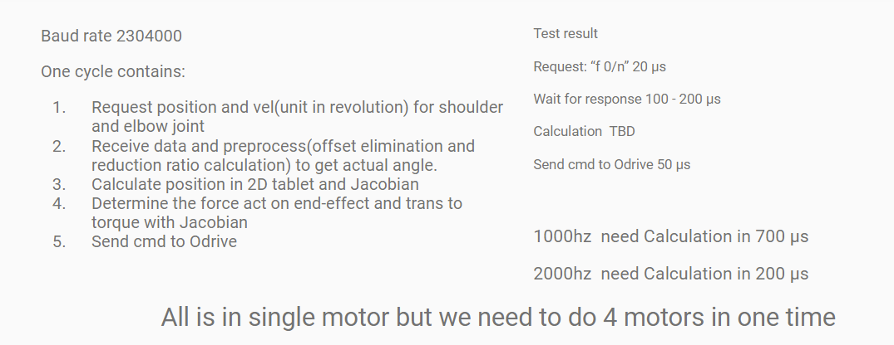
* Made an additional determination about the system architecture: have 1 odrive controlling shoulders, and the other controlling elbows. This will allow us to control 1 arm quite quickly by utilizing the parallel Odrives. With the entire system running at around ~2000 hz ideally, we can switch back and forth between the two arms, effectively running each at 1000 hz
* 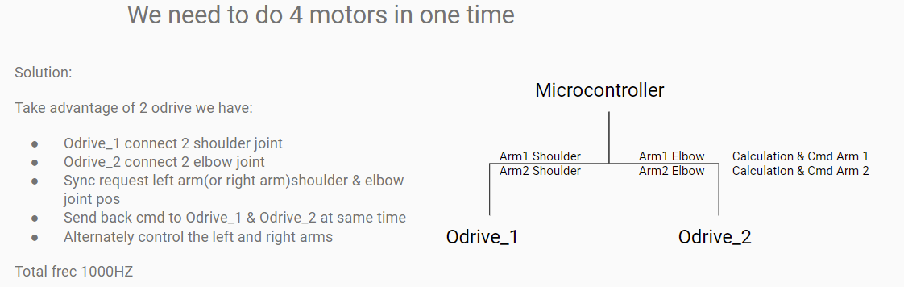

**Magnet**

* Attempted new puck design with different thrust bearings: besides the sizing of the pucks becoming unnecessarily large, none of the new bearings provided significant improvement
* Decided on new set of magnet that compensate for normal force lost with the screen usage
* Figure a method to have the magnet recognized on the screen

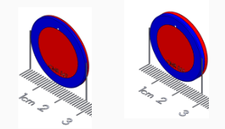

**Mechanical**

This week, we got the design of the alpha prototype finalized, and ordered stock. We also started to manufacture components. All the water jetting is done, and we are finished with approximately 40% of the machined parts.. Our plan is to be done with most of the parts and the 8020 frame by next Wednesday, aiming to assemble as early as possible.

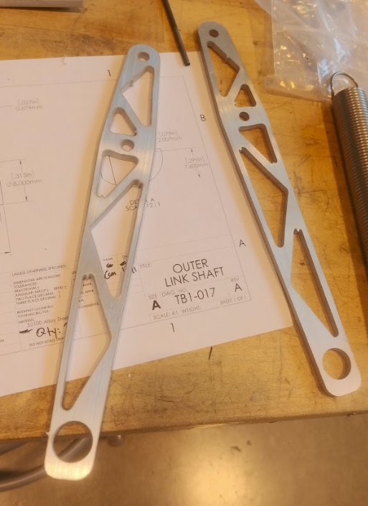

# Meeting with Professors

## 

**Embedded**

**Electronics**

**Magnet**

**Manufacturing/Mechanical**

* Also still add limit switches

Email Billy w specific broche needed

**Magnets**

Bill drew field lines - are they cones? - smth about measurements? Have the top one be on the screen and have the bottom one have a varied height

Test with a thicker conventional magnet for the top - aim at reducing screen occupation - let’s try to stack up some magnets

**Electronics**

What types of experiences can we create that will be less dependent on the drivability of the display- maybe take spots on the screen and make them magnetic underneath them

**Embedded**

Let’s try to do some motion control - have the robot move in a circle or a path we define, and see how effective it is on driving our finger around that path. So put an image on the screen and then the robot moves around the outline. Then we go to actual haptics where we are the ones making the movement